# Week 3 Solution

## Exercise 1: Configuring a Basic Spring Application

This document outlines the implementation of a basic Spring application for a **Library Management System** using Maven and VS Code. It includes the project structure, code files, compilation and execution steps.

### 1. Project Structure

LibraryManagement/  
├── src/  
│ └── main/  
│ ├── java/  
│ │ └── com/  
│ │ └── library/  
│ │ ├── MainApp.java  
│ │ ├── service/  
│ │ │ └── BookService.java  
│ │ └── repository/  
│ │ └── BookRepository.java  
│ └── resources/  
│ └── applicationContext.xml  
├── pom.xml

### 2. pom.xml Dependency

Add the following dependency to your pom.xml file:

**<dependencies>  
 <dependency>  
 <groupId>org.springframework</groupId>  
 <artifactId>spring-context</artifactId>  
 <version>5.3.20</version>  
 </dependency>  
</dependencies>**

### 3. applicationContext.xml

**<beans xmlns="http://www.springframework.org/schema/beans"  
 xmlns:xsi="http://www.w3.org/2001/XMLSchema-instance"  
 xsi:schemaLocation="http://www.springframework.org/schema/beans  
 http://www.springframework.org/schema/beans/spring-beans.xsd">  
  
 <bean id="bookRepository" class="com.library.repository.BookRepository"/>  
 <bean id="bookService" class="com.library.service.BookService">  
 <property name="bookRepository" ref="bookRepository"/>  
 </bean>  
</beans>**

### 4. Java Source Files

**BookRepository.java**

package com.library.repository;  
  
public class BookRepository {  
 public String getBook() {  
 return "Spring in Action";  
 }  
}

**BookService.java**

package com.library.service;  
  
import com.library.repository.BookRepository;  
  
public class BookService {  
 private BookRepository bookRepository;  
  
 public void setBookRepository(BookRepository bookRepository) {  
 this.bookRepository = bookRepository;  
 }  
  
 public void displayBook() {  
 System.out.println("Book: " + bookRepository.getBook());  
 }  
}

**MainApp.java**

package com.library;  
  
import com.library.service.BookService;  
import org.springframework.context.ApplicationContext;  
import org.springframework.context.support.ClassPathXmlApplicationContext;  
  
public class MainApp {  
 public static void main(String[] args) {  
 ApplicationContext context = new ClassPathXmlApplicationContext("applicationContext.xml");  
 BookService bookService = (BookService) context.getBean("bookService");  
 bookService.displayBook();  
 }  
}

### 5. Compilation and Execution Commands

# Compile the project  
**mvn compile**  
  
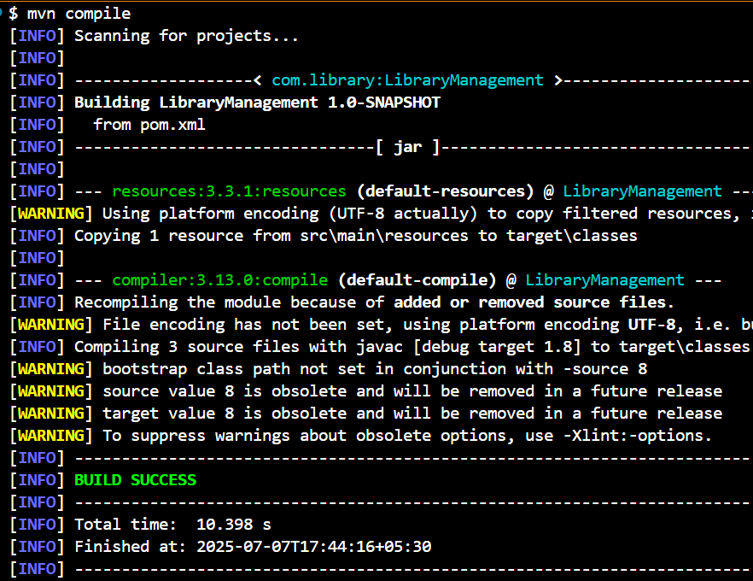

# Run the project  
**mvn exec:java -Dexec.mainClass="com.library.MainApp"**

